|  |  |
| --- | --- |
|  |  |

**Tableau Workbook Name: Superstore.twbx**

|  |  |
| --- | --- |
| Background: |  |

|  |  |  |  |
| --- | --- | --- | --- |
| Requested by: |  | Requested date: |  |

|  |  |  |  |
| --- | --- | --- | --- |
| Developed by: |  | Completed date: |  |

|  |  |
| --- | --- |
| Audience: |  |

# Table of Contents

1. General Information
   1. Summary Stats
   2. Data Source
   3. Worksheets Mapping
   4. Tables and Fields
   5. Calculated Fields
   6. Hierarchies
   7. Parameters
   8. Workbook Map
2. Unused Objects in Workbook
   1. Unused Fields
   2. Unused Worksheets
   3. Unused Calculations
3. Dashboards
   1. Commission Model
   2. Customers
   3. Order Details
   4. Overview
   5. Product
   6. Shipping
4. Worksheets
   1. CommissionProjection
   2. CustomerOverview
   3. CustomerRank
   4. CustomerScatter
   5. DaystoShip
   6. Forecast
   7. OTE
   8. Performance
   9. Product Detail Sheet
   10. ProductDetails
   11. ProductView
   12. QuotaAttainment
   13. Sale Map
   14. Sales
   15. Sales by Product
   16. Sales by Segment
   17. ShipSummary
   18. ShippingTrend
   19. Tooltip: Profit Ratio by City
   20. Total Sales
   21. What If Forecast

## Summary Stats

|  |  |
| --- | --- |
|  | **Counts** |
| Dashboards # | 6 |
| Worksheets # | 21 |
| Data Source # | 3 |
| Data Source Filters | 0 |
| Custom SQL # | 0 |
| Fields # | 33 |
| Calculated Fields # | 21 |
| Groups # | 0 |
| Hierarchies # | 2 |
| Parameters # | 6 |
| Sets # | 0 |
| Stories # | 0 |

## Data Source

|  |  |  |  |
| --- | --- | --- | --- |
| **Data Source Alias** | **Data Source Type** | **Source** | **Joins** |
| Sales Target | Live | excel-direct | None |
| Sales Commission | Live | textscan | None |
| Sample - Superstore | Live | excel-direct | [Region (Orders$)] join [Region (People)] join [Order ID (Orders$)] join [Order ID (Returns)] |

## Worksheets Mapping

|  |  |  |  |
| --- | --- | --- | --- |
| **Dashboard/Storyboard Name** | **Worksheet Name** | **Object Type (Dashboard/Storyboard)** | **Used?** |
| Commission Model | QuotaAttainment | Dashboard | Yes |
| Commission Model | CommissionProjection | Dashboard | Yes |
| Commission Model | Sales | Dashboard | Yes |
| Commission Model | OTE | Dashboard | Yes |
| Customers | CustomerScatter | Dashboard | Yes |
| Customers | CustomerRank | Dashboard | Yes |
| Customers | CustomerOverview | Dashboard | Yes |
| Order Details | Product Detail Sheet | Dashboard | Yes |
| Overview | Total Sales | Dashboard | Yes |
| Overview | Sale Map | Dashboard | Yes |
| Overview | Sales by Segment | Dashboard | Yes |
| Overview | Sales by Product | Dashboard | Yes |
| Overview | Tooltip: Profit Ratio by City (Used in Sale Map as a Tooltip) | Dashboard | Yes |
| Product | ProductView | Dashboard | Yes |
| Product | ProductDetails | Dashboard | Yes |
| Shipping | ShipSummary | Dashboard | Yes |
| Shipping | ShippingTrend | Dashboard | Yes |
| Shipping | DaystoShip | Dashboard | Yes |
| N/A | Forecast | N/A | No |
| N/A | Performance | N/A | No |
| N/A | What If Forecast | N/A | No |

## Tables and Fields

|  |  |  |  |  |  |  |  |  |
| --- | --- | --- | --- | --- | --- | --- | --- | --- |
| **Data Source** | **Source Database** | **Table Name** | **Field Name** | **Remote Field** | **Data Type** | **Used?** | **Dimension/ Measure** | **Hidden** |
| Sales Commission | textscan | Sales Commission.csv | Sales Person | Sales Person | string | Yes | Dimension | No |
| Sales Commission | textscan | Sales Commission.csv | Order Date | Order Date | datetime | No | Dimension | No |
| Sales Commission | textscan | Sales Commission.csv | Region | Region | string | No | Dimension | No |
| Sales Target | excel-direct | Sheet1 | Category | Category | string | No | Dimension | No |
| Sales Target | excel-direct | Sheet1 | Order Date | Order Date | date | No | Dimension | No |
| Sales Target | excel-direct | Sheet1 | Segment | Segment | string | No | Dimension | No |
| Sample - Superstore | excel-direct | Orders | Order ID | Order ID | string | Yes | Dimension | No |
| Sample - Superstore | excel-direct | Orders | Order Date | Order Date | date | Yes | Dimension | No |
| Sample - Superstore | excel-direct | Orders | Ship Date | Ship Date | date | Yes | Dimension | No |
| Sample - Superstore | excel-direct | Orders | Ship Mode | Ship Mode | string | Yes | Dimension | No |
| Sample - Superstore | excel-direct | Orders | Customer Name | Customer Name | string | Yes | Dimension | No |
| Sample - Superstore | excel-direct | Orders | Segment | Segment | string | Yes | Dimension | No |
| Sample - Superstore | excel-direct | Orders | Country/Region | Country/Region | string | Yes | Dimension | No |
| Sample - Superstore | excel-direct | Orders | City | City | string | Yes | Dimension | No |
| Sample - Superstore | excel-direct | Orders | State/Province | State/Province | string | Yes | Dimension | No |
| Sample - Superstore | excel-direct | Orders | Postal Code | Postal Code | string | Yes | Dimension | No |
| Sample - Superstore | excel-direct | Orders | Region | Region | string | Yes | Dimension | No |
| Sample - Superstore | excel-direct | Orders | Category | Category | string | Yes | Dimension | No |
| Sample - Superstore | excel-direct | Orders | Sub-Category | Sub-Category | string | Yes | Dimension | No |
| Sample - Superstore | excel-direct | Orders | Product Name | Product Name | string | Yes | Dimension | No |
| Sample - Superstore | excel-direct | People | Region | Region | string | Yes | Dimension | No |
| Sample - Superstore | excel-direct | Returns | Order ID | Order ID | string | Yes | Dimension | No |
| Sample - Superstore | excel-direct | Orders | Row ID | Row ID | integer | No | Dimension | No |
| Sample - Superstore | excel-direct | Orders | Customer ID | Customer ID | string | No | Dimension | No |
| Sample - Superstore | excel-direct | Orders | Product ID | Product ID | string | No | Dimension | No |
| Sample - Superstore | excel-direct | People | Regional Manager | Regional Manager | string | No | Dimension | No |
| Sample - Superstore | excel-direct | Returns | Returned | Returned | string | No | Dimension | No |
| Sales Commission | textscan | Sales Commission.csv | Sales | Sales | integer | Yes | Measure | No |
| Sales Target | excel-direct | Sheet1 | Sales Target | Sales Target | integer | Yes | Measure | No |
| Sample - Superstore | excel-direct | Orders | Sales | Sales | real | Yes | Measure | No |
| Sample - Superstore | excel-direct | Orders | Quantity | Quantity | integer | Yes | Measure | No |
| Sample - Superstore | excel-direct | Orders | Discount | Discount | real | Yes | Measure | No |
| Sample - Superstore | excel-direct | Orders | Profit | Profit | real | Yes | Measure | No |

## Calculated Fields

|  |  |  |  |  |  |
| --- | --- | --- | --- | --- | --- |
| **Calculated Field Name** | **Tableau Field Name** | **Data Source Name** | **Formula** | **Used?** | **Dimension/ Measure** |
| Estimate Compensation label | Estimate Compensation label | Sales Commission | "Estimated Compensation:" | No | Dimension |
| Total Sales label | Total Sales label | Sales Commission | "Total Sales:" | No | Dimension |
| Achievement (estimated) | Achievement (copy) | Sales Commission | [Sales] | Yes | Measure |
| Achieved Quota | Achievement (variable) (copy) | Sales Commission | if SUM([Achievement (estimated)]) >= [New Quota] then "100% +" elseif SUM([Achievement (estimated)]) >= 0.75 * [Parameters].[New Quota] then "75-100%" elseif SUM([Achievement (estimated)]) >= 0.5 * [Parameters].[New Quota] then "50-75%" else "Below 50%" end | Yes | Measure |
| Base (Variable) | Base (Variable) | Sales Commission | [Base Salary] | Yes | Measure |
| % of quota achieved | Calculation_0440925131659539 | Sales Commission | AVG([Achievement (estimated)])/[New Quota] | Yes | Measure |
| Rank over 3 | Calculation_4120925132203686 | Sales Commission | ROUND(INDEX() / 3 - 0.6,0) + 1 | Yes | Measure |
| Sort by field | Calculation_8140925133029303 | Sales Commission | if [Sort by]="Names" then 0 elseif [Parameters].[Sort by]="% quota descending" then -[% of quota achieved] else [% of quota achieved] end | Yes | Measure |
| Commission (Variable) | Commission (Variable) | Sales Commission | ([Commission Rate]*[Sales])/100 | Yes | Measure |
| OTE (Variable) | OTE (Variable) | Sales Commission | [Base Salary] + ([Parameters].[Commission Rate]*[Parameters].[New Quota])/100 | Yes | Measure |
| Total Compensation | Total Compensation | Sales Commission | MIN([Base (Variable)]) + SUM([Commission (Variable)]) | Yes | Measure |
| Ship Status | Calculation_6401103171259723 | Sample - Superstore | if [Days to Ship Actual]> [Days to Ship Scheduled] then "Shipped Late" elseIF [Days to Ship Actual]= [Days to Ship Scheduled] then "Shipped On Time" Else "Shipped Early" end | Yes | Dimension |
| Order Profitable? | Calculation_9060122104947471 | Sample - Superstore | {fixed [Order ID]:sum([Profit])}>0 // calculates the profit at the order level | Yes | Dimension |
| Days to Ship Actual | Calculation_0831103151444568 | Sample - Superstore | DATEDIFF('day',[Order Date],[Ship Date]) | Yes | Measure |
| Sales Forecast | Calculation_5421109230915137 | Sample - Superstore | [Sales]*(1-[Churn Rate])*(1+[Parameters].[New Business Growth]) | Yes | Measure |
| Days to Ship Scheduled | Calculation_6861103170623145 | Sample - Superstore | CASE [Ship Mode] WHEN "Same Day" THEN 0 WHEN "First Class" THEN 1 WHEN "Second Class" THEN 3 WHEN "Standard Class" THEN 6 END | Yes | Measure |
| Sales per Customer | Calculation_9321103144526191 | Sample - Superstore | Sum([Sales])/countD([Customer Name]) | Yes | Measure |
| Profit Ratio | Calculation_9921103144103743 | Sample - Superstore | sum([Profit])/sum([Sales]) | Yes | Measure |
| Sales above Target? | Calculation_9951107165644870 | Sample - Superstore | If Sum([Sales])>SUM([Sales Target].[Sales Target]) then "Above Target" else "Below Target" end | Yes | Measure |
| Units estimate | Sales est (copy) | Sample - Superstore | ROUND([Quantity]*(1-[Churn Rate])*(1+[Parameters].[New Business Growth]),0) | Yes | Measure |
| Profit per Order | Sales per Customer (copy) | Sample - Superstore | Sum([Profit])/countD([Order ID]) | Yes | Measure |

## Hierarchies

|  |  |  |  |
| --- | --- | --- | --- |
| **Hierarchy Name** | **Fields** | **Data Source Name** | **Used?** |
| Location | Country/Region, Region, State/Province, City, Postal Code | Sample - Superstore | Yes |
| Product | Category, Sub-Category, Product Name | Sample - Superstore | Yes |

## Parameters

|  |  |  |  |  |  |
| --- | --- | --- | --- | --- | --- |
| **Parameter Name** | **Data Type** | **Allowable Value type** | **Current Value** | **Values** | **Used?** |
| Base Salary | Integer | Range | 50000 | Min: 0, Step size: 1000 | Yes |
| Commission Rate | Float | Range | 18.399999999999999 | Min: 1.0, Max: 100.0, Step size: 0.10000000000000001 | Yes |
| New Quota | Integer | Range | 500000 | Min: 100000, Step size: 25000 | Yes |
| Sort by | String | List | Names | % quota ascending, % quota descending, Names | Yes |
| New Business Growth | Float | Range | 0.59999999999999998 | Min: 0.0, Max: 1.0, Step size: 0.01 | Yes |
| Churn Rate | Float | Range | 0.064000000000000001 | Min: 0.0, Max: 0.25, Step size: 0.001 | Yes |

## Workbook Map

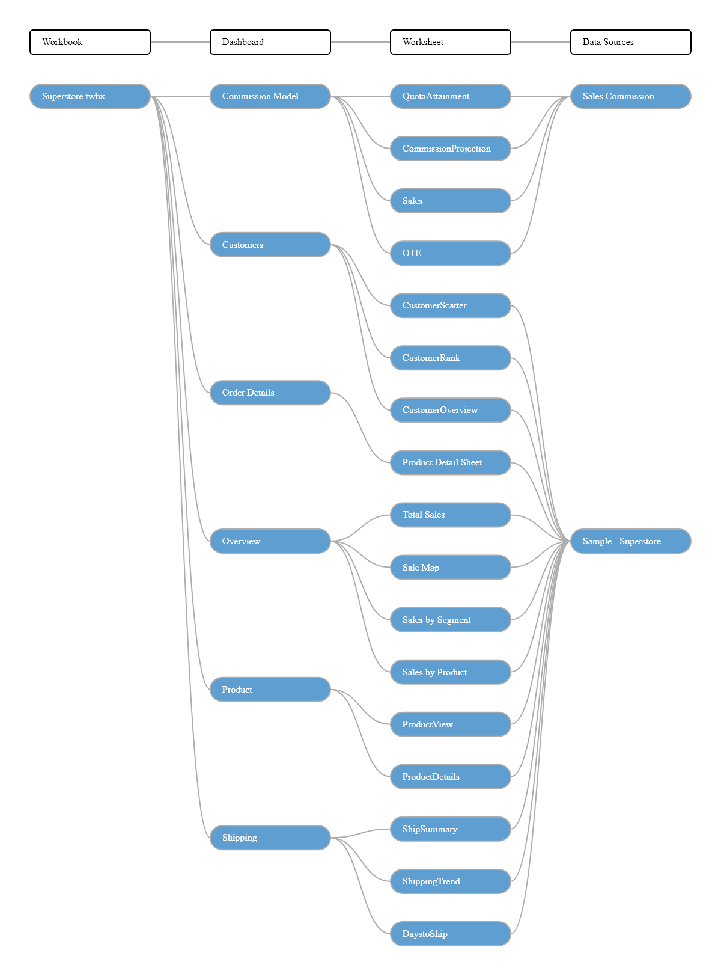

# Unused Objects in Workbook

## Unused Fields

|  |  |
| --- | --- |
| **Data Source Alias** | **Field Name** |
| Sales Commission | Order Date |
| Sales Commission | Region |
| Sales Target | Category |
| Sales Target | Order Date |
| Sales Target | Segment |
| Sample - Superstore | Row ID |
| Sample - Superstore | Customer ID |
| Sample - Superstore | Product ID |
| Sample - Superstore | Regional Manager |
| Sample - Superstore | Returned |

## Unused Worksheets

* Forecast
* Performance
* What If Forecast

## Unused Calculations

* Estimate Compensation label
* Total Sales label

# **Dashboards**

## Dashboard Name: Commission Model

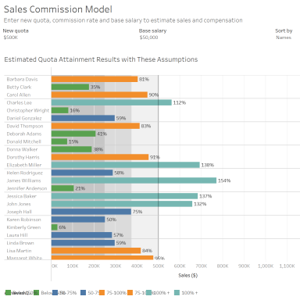

### "Commission Model" Summary Stats

|  |  |
| --- | --- |
|  | **Counts** |
| Worksheets # | 4 |
| Parameters # | 4 |
| Quick Filters # | 0 |
| Actions # | 1 |

### Below Worksheets were used in "Commission Model" Dashboard

* QuotaAttainment
* CommissionProjection
* Sales
* OTE

### Parameters used

* New Quota
* Base Salary
* Sort by
* Commission Rate

### Actions

|  |  |  |  |  |  |
| --- | --- | --- | --- | --- | --- |
| **Action Name** | **Action Type** | **Source Sheet** | **Target Sheet** | **Run Action On** | **Target Filter** |
| Highlight 3 (generated) 1 | Highlight | QuotaAttainment, CommissionProjection, Sales, OTE | QuotaAttainment, CommissionProjection | on-select | Selected (Sales Person) |

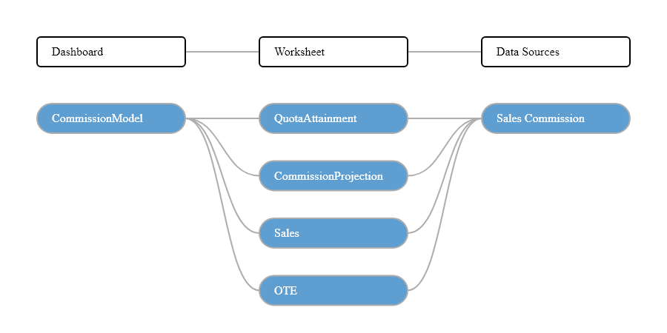

## Dashboard Name: Customers

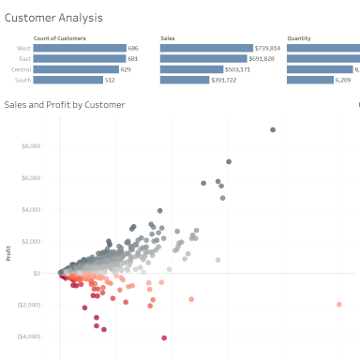

### "Customers" Summary Stats

|  |  |
| --- | --- |
|  | **Counts** |
| Worksheets # | 3 |
| Parameters # | 0 |
| Quick Filters # | 3 |
| Actions # | 3 |

### Below Worksheets were used in "Customers" Dashboard

* CustomerScatter
* CustomerRank
* CustomerOverview

### Quick Filters Applied

|  |  |  |
| --- | --- | --- |
| **Field Name** | **Sheet Name** | **Apply to** |
| Order Date | CustomerOverview, CustomerRank, CustomerScatter, DaystoShip, Performance, ProductDetails, ProductView, ShipSummary, ShippingTrend, What If Forecast | Selected |
| Category | CustomerOverview, CustomerRank, CustomerScatter, Product Detail Sheet, ProductView | Selected |
| Segment | CustomerOverview, CustomerRank, CustomerScatter, Product Detail Sheet | Selected |

### Actions

|  |  |  |  |  |  |
| --- | --- | --- | --- | --- | --- |
| **Action Name** | **Action Type** | **Source Sheet** | **Target Sheet** | **Run Action On** | **Target Filter** |
| Highlight Customer Name (Hover) 1 | Highlight | CustomerScatter, CustomerRank | CustomerScatter, CustomerRank | on-hover | Selected (Customer Name) |
| Filter Region 1 | Filter | CustomerOverview | CustomerScatter, CustomerRank | on-select | Selected (Region) |
| Highlight 1 (generated) 1 | Highlight | CustomerScatter, CustomerRank | CustomerScatter, CustomerRank | on-select | all |

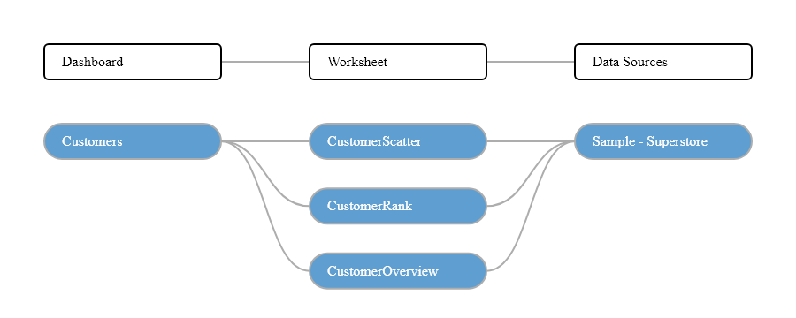

## Dashboard Name: Order Details

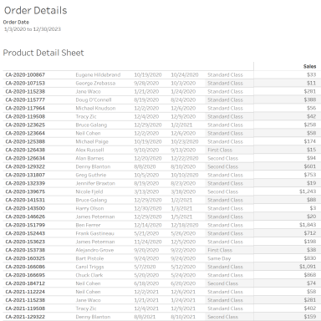

### "Order Details" Summary Stats

|  |  |
| --- | --- |
|  | **Counts** |
| Worksheets # | 1 |
| Parameters # | 0 |
| Quick Filters # | 6 |
| Actions # | 0 |

### Below Worksheets were used in "Order Details" Dashboard

* Product Detail Sheet

### Quick Filters Applied

|  |  |  |
| --- | --- | --- |
| **Field Name** | **Sheet Name** | **Apply to** |
| Order Date | CustomerOverview, CustomerRank, CustomerScatter, Forecast, Product Detail Sheet, ProductDetails, Sale Map, Sales by Product, Sales by Segment, Tooltip: Profit Ratio by City, Total Sales, What If Forecast | Selected |
| Region | CustomerOverview, CustomerRank, CustomerScatter, DaystoShip, Forecast, Performance, Product Detail Sheet, ProductDetails, ProductView, Sale Map, Sales by Product, Sales by Segment, ShipSummary, ShippingTrend, Total Sales, What If Forecast | Selected |
| State/Province | Product Detail Sheet | All |
| City | Product Detail Sheet | All |
| Category | CustomerOverview, CustomerRank, CustomerScatter, Product Detail Sheet, ProductView | Selected |
| Segment | CustomerOverview, CustomerRank, CustomerScatter, Product Detail Sheet | Selected |

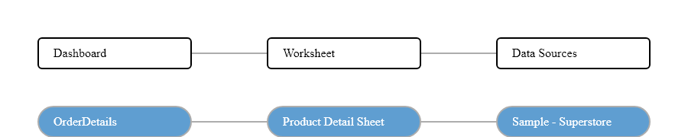

## Dashboard Name: Overview

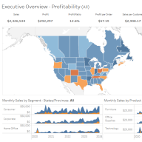

### "Overview" Summary Stats

|  |  |
| --- | --- |
|  | **Counts** |
| Worksheets # | 4 |
| Parameters # | 0 |
| Quick Filters # | 3 |
| Actions # | 3 |

### Below Worksheets were used in "Overview" Dashboard

* Total Sales
* Sale Map
* Sales by Segment
* Sales by Product

### Quick Filters Applied

|  |  |  |
| --- | --- | --- |
| **Field Name** | **Sheet Name** | **Apply to** |
| Region | CustomerOverview, CustomerRank, CustomerScatter, DaystoShip, Forecast, Performance, Product Detail Sheet, ProductDetails, ProductView, Sale Map, Sales by Product, Sales by Segment, ShipSummary, ShippingTrend, Total Sales, What If Forecast | Selected |
| Order Date | CustomerOverview, CustomerRank, CustomerScatter, Forecast, Product Detail Sheet, ProductDetails, Sale Map, Sales by Product, Sales by Segment, Tooltip: Profit Ratio by City, Total Sales, What If Forecast | Selected |
| Profit Ratio | Sale Map | Only this |

### Actions

|  |  |  |  |  |  |
| --- | --- | --- | --- | --- | --- |
| **Action Name** | **Action Type** | **Source Sheet** | **Target Sheet** | **Run Action On** | **Target Filter** |
| State/Province Filter 1 | Filter | Sale Map | Total Sales, Sales by Segment, Sales by Product | on-select | Selected (State/Province) |
| State/Province Highlight (map) 1 | Highlight | Total Sales, Sale Map | Total Sales, Sale Map | on-select | Selected (State/Province) |
| Month Highlight 1 | Highlight | Total Sales, Sales by Segment, Sales by Product | Total Sales, Sales by Segment, Sales by Product | on-select | Selected (MONTH(Order Date),Order Profitable?) |

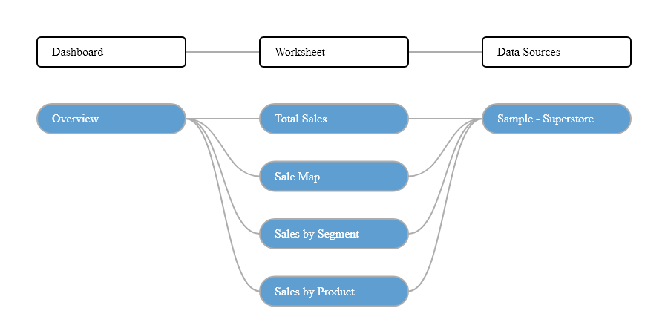

## Dashboard Name: Product

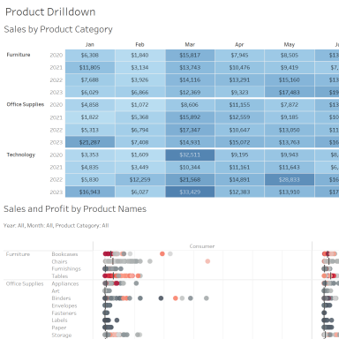

### "Product" Summary Stats

|  |  |
| --- | --- |
|  | **Counts** |
| Worksheets # | 2 |
| Parameters # | 0 |
| Quick Filters # | 1 |
| Actions # | 1 |

### Below Worksheets were used in "Product" Dashboard

* ProductView
* ProductDetails

### Quick Filters Applied

|  |  |  |
| --- | --- | --- |
| **Field Name** | **Sheet Name** | **Apply to** |
| Region | CustomerOverview, CustomerRank, CustomerScatter, DaystoShip, Forecast, Performance, Product Detail Sheet, ProductDetails, ProductView, Sale Map, Sales by Product, Sales by Segment, ShipSummary, ShippingTrend, Total Sales, What If Forecast | Selected |

### Actions

|  |  |  |  |  |  |
| --- | --- | --- | --- | --- | --- |
| **Action Name** | **Action Type** | **Source Sheet** | **Target Sheet** | **Run Action On** | **Target Filter** |
| Filter Product Sales 1 | Filter | ProductView | ProductView, ProductDetails | on-select | All |

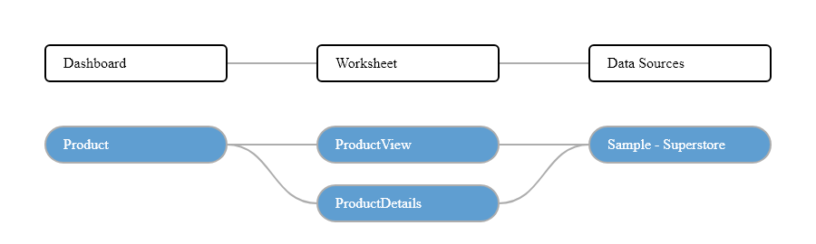

## Dashboard Name: Shipping

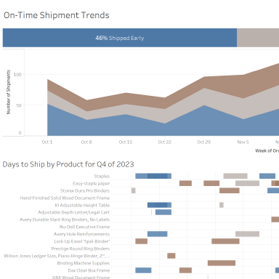

### "Shipping" Summary Stats

|  |  |
| --- | --- |
|  | **Counts** |
| Worksheets # | 3 |
| Parameters # | 0 |
| Quick Filters # | 3 |
| Actions # | 2 |

### Below Worksheets were used in "Shipping" Dashboard

* ShipSummary
* ShippingTrend
* DaystoShip

### Quick Filters Applied

|  |  |  |
| --- | --- | --- |
| **Field Name** | **Sheet Name** | **Apply to** |
| Order Date | CustomerOverview, CustomerRank, CustomerScatter, DaystoShip, Performance, ProductDetails, ProductView, ShipSummary, ShippingTrend, What If Forecast | Selected |
| Region | CustomerOverview, DaystoShip, ShipSummary, ShippingTrend | Selected |
| Ship Mode | CustomerOverview, CustomerRank, CustomerScatter, DaystoShip, Forecast, Performance, Product Detail Sheet, ProductDetails, ProductView, Sale Map, Sales by Product, Sales by Segment, ShipSummary, ShippingTrend, Total Sales, What If Forecast | Selected |

### Actions

|  |  |  |  |  |  |
| --- | --- | --- | --- | --- | --- |
| **Action Name** | **Action Type** | **Source Sheet** | **Target Sheet** | **Run Action On** | **Target Filter** |
| Filter Details 1 | Filter | ShippingTrend | ShippingTrend, DaystoShip | on-select | All |
| Filter 1 (generated) 1 | Filter | ShipSummary | ShipSummary, ShippingTrend, DaystoShip | on-select | All |

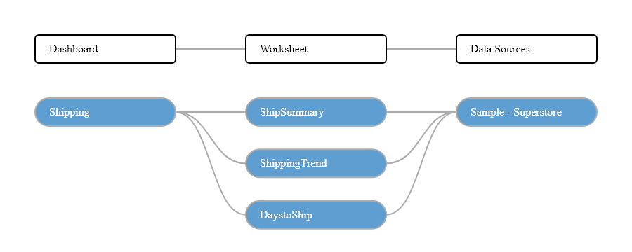

# **Worksheets**

## Worksheet Name: CommissionProjection

### Worksheet was used in the following Dashboards

* Commission Model

### Data Sources

|  |  |  |  |
| --- | --- | --- | --- |
| **Data Source Alias** | **Data Source Type** | **Source** | **Joins** |
| Sales Commission | Live | textscan | None |

### Filters

|  |  |  |  |  |  |
| --- | --- | --- | --- | --- | --- |
| **Field Name** | **Field Selection** | **Field Wildcard** | **Field Condition** | **Field Limit** | **Context Filter** |
| Measure Names Sum(Commission ) | Selected from list | All | None | None | No |
| Measure Names Min(Base ) | Selected from list | All | None | None | No |

### Marks

|  |  |
| --- | --- |
| **Object(s) Used** | **Mark Type** |
| Measure Names | Color |
| Sum (Achievement (estimated)) | Detail |
| Custom (Total Compensation) | Detail |
| Maximum (OTE (Variable)) | Detail |
| Custom (Total Compensation) | Detail |
| Custom (Achieved Quota) | Detail |

### Calculated Fields

|  |  |
| --- | --- |
| **Field Name** | **Formula** |
| Achievement (estimated) | [Sales] |
| Achieved Quota | if SUM([Achievement (estimated)]) >= [New Quota] then "100% +" elseif SUM([Achievement (estimated)]) >= 0.75 * [New Quota] then "75-100%" elseif SUM([Achievement (estimated)]) >= 0.5 * [Parameters].[New Quota] then "50-75%" else "Below 50%" end |
| Base (Variable) | [Base Salary] |
| % of quota achieved | AVG([Achievement (estimated)])/[New Quota] |
| Rank over 3 | ROUND(INDEX() / 3 - 0.6,0) + 1 |
| Sort by field | if [Sort by]="Names" then 0 elseif [Sort by]="% quota descending" then -[% of quota achieved] else [% of quota achieved] end |
| Commission (Variable) | ([Commission Rate]*[Sales])/100 |
| OTE (Variable) | [Base Salary] + ([Commission Rate]*[Parameters].[New Quota])/100 |
| Total Compensation | MIN([Base (Variable)]) + SUM([Commission (Variable)]) |

### Columns and Rows

|  |  |
| --- | --- |
| **Field Name** | **Column/Row** |
| Custom (Rank over 3) | Rows |
| Sales Person | Rows |
| Measure Values | Columns |

### Applied Sortings

|  |  |  |  |  |
| --- | --- | --- | --- | --- |
| **Field Name** | **Sort By** | **Sort Order** | **Aggregation Field** | **Aggregation Type** |
| Sales Person | Field | Ascending | Sort by field | Custom |
| Measure Names | Manual | NA | NA | NA |
| Achieved Quota | Manual | NA | NA | NA |

## Worksheet Name: CustomerOverview

### Worksheet was used in the following Dashboards

* Customers

### Data Sources

|  |  |  |  |
| --- | --- | --- | --- |
| **Data Source Alias** | **Data Source Type** | **Source** | **Joins** |
| Sample - Superstore | Live | excel-direct | [Region (Orders$)] join [Region (People)] join [Order ID (Orders$)] join [Order ID (Returns)] |

### Filters

|  |  |  |  |  |  |  |
| --- | --- | --- | --- | --- | --- | --- |
| **Field Name** | **Field Selection** | **Selected Field Value(s)** | **Field Wildcard** | **Field Condition** | **Field Limit** | **Context Filter** |
| Measure Names CountD(Customer Name) | Selected from list |  | All | None | None | No |
| Measure Names Sum(Sales) | Selected from list |  | All | None | None | No |
| Measure Names Sum(Quantity) | Selected from list |  | All | None | None | No |
| Measure Names (Sales per Customer) | Selected from list |  | All | None | None | No |
| Measure Names Sum(Profit) | Selected from list |  | All | None | None | No |
| Measure Names (Profit Ratio) | Selected from list |  | All | None | None | No |
| Category | Use all |  | All | None | None | No |
| Order Date | In-Range | From 2020-01-03 to 2023-12-30 | All | None | max[#2023-12-30#], min[#2020-01-03#] | No |
| Region | Use all |  | All | None | None | No |
| Segment | Use all |  | All | None | None | No |
| Order Date | Selected from list | None | All | None | None | No |
| Order Date | Use all |  | All | None | None | No |

### Actions

|  |  |  |  |  |
| --- | --- | --- | --- | --- |
| **Action Name** | **Source Sheet** | **Target Sheet** | **Run Action On** | **Target Filter** |
| Filter Region 1 | CustomerOverview | CustomerScatter, CustomerRank | on-select | Selected (Region) |

### Marks

|  |  |
| --- | --- |
| **Object(s) Used** | **Mark Type** |
| Count (Distinct) (Customer Name) | Detail |
| Sum (Sales) | Detail |
| Sum (Quantity) | Detail |
| Custom (Sales per Customer) | Detail |
| Sum (Profit) | Detail |
| Custom (Profit Ratio) | Detail |

### Calculated Fields

|  |  |
| --- | --- |
| **Field Name** | **Formula** |
| Days to Ship Actual | DATEDIFF('day',[Order Date],[Ship Date]) |
| Days to Ship Scheduled | CASE [Ship Mode] WHEN "Same Day" THEN 0 WHEN "First Class" THEN 1 WHEN "Second Class" THEN 3 WHEN "Standard Class" THEN 6 END |
| Sales per Customer | Sum([Sales])/countD([Customer Name]) |
| Profit Ratio | sum([Profit])/sum([Sales]) |

### Columns and Rows

|  |  |
| --- | --- |
| **Field Name** | **Column/Row** |
| Region | Rows |
| Measure Names | Columns |
| Measure Values | Columns |

### Applied Sortings

|  |  |  |  |  |
| --- | --- | --- | --- | --- |
| **Field Name** | **Sort By** | **Sort Order** | **Aggregation Field** | **Aggregation Type** |
| Region | Field | Descending | Customer Name | Count (Distinct) |
| Measure Names | Manual | NA | NA | NA |

## Worksheet Name: CustomerRank

### Worksheet was used in the following Dashboards

* Customers

### Data Sources

|  |  |  |  |
| --- | --- | --- | --- |
| **Data Source Alias** | **Data Source Type** | **Source** | **Joins** |
| Sample - Superstore | Live | excel-direct | [Region (Orders$)] join [Region (People)] join [Order ID (Orders$)] join [Order ID (Returns)] |

### Filters

|  |  |  |  |  |  |  |
| --- | --- | --- | --- | --- | --- | --- |
| **Field Name** | **Field Selection** | **Selected Field Value(s)** | **Field Wildcard** | **Field Condition** | **Field Limit** | **Context Filter** |
| Action (Region) | Use all |  | All | None | None | No |
| Category | Use all |  | All | None | None | No |
| Order Date | In-Range | From 2020-01-03 to 2023-12-30 | All | None | max[#2023-12-30#], min[#2020-01-03#] | No |
| Region | Use all |  | All | None | None | No |
| Segment | Use all |  | All | None | None | No |
| Order Date | Use all |  | All | None | None | No |

### Actions

|  |  |  |  |  |
| --- | --- | --- | --- | --- |
| **Action Name** | **Source Sheet** | **Target Sheet** | **Run Action On** | **Target Filter** |
| Highlight Customer Name (Hover) 1 | CustomerScatter, CustomerRank | CustomerScatter, CustomerRank | on-hover | Selected (Customer Name) |
| Highlight 1 (generated) 1 | CustomerScatter, CustomerRank | CustomerScatter, CustomerRank | on-select | all |

### Marks

|  |  |
| --- | --- |
| **Object(s) Used** | **Mark Type** |
| Custom (Profit Ratio) | Color |
| Sum (Profit) | Tooltip |
| Sum (Sales) | Detail |

### Calculated Fields

|  |  |
| --- | --- |
| **Field Name** | **Formula** |
| Profit Ratio | sum([Profit])/sum([Sales]) |

### Columns and Rows

|  |  |
| --- | --- |
| **Field Name** | **Column/Row** |
| Customer Name | Rows |
| Sum (Sales) | Columns |

### Applied Sortings

|  |  |  |  |  |
| --- | --- | --- | --- | --- |
| **Field Name** | **Sort By** | **Sort Order** | **Aggregation Field** | **Aggregation Type** |
| Customer Name | Field | Descending | Sales | Sum |

## Worksheet Name: CustomerScatter

### Worksheet was used in the following Dashboards

* Customers

### Data Sources

|  |  |  |  |
| --- | --- | --- | --- |
| **Data Source Alias** | **Data Source Type** | **Source** | **Joins** |
| Sample - Superstore | Live | excel-direct | [Region (Orders$)] join [Region (People)] join [Order ID (Orders$)] join [Order ID (Returns)] |

### Filters

|  |  |  |  |  |  |  |
| --- | --- | --- | --- | --- | --- | --- |
| **Field Name** | **Field Selection** | **Selected Field Value(s)** | **Field Wildcard** | **Field Condition** | **Field Limit** | **Context Filter** |
| Action (Region) | Use all |  | All | None | None | No |
| Category | Use all |  | All | None | None | No |
| Order Date | In-Range | From 2020-01-03 to 2023-12-30 | All | None | max[#2023-12-30#], min[#2020-01-03#] | No |
| Region | Use all |  | All | None | None | No |
| Segment | Use all |  | All | None | None | No |
| Order Date | Use all |  | All | None | None | No |

### Actions

|  |  |  |  |  |
| --- | --- | --- | --- | --- |
| **Action Name** | **Source Sheet** | **Target Sheet** | **Run Action On** | **Target Filter** |
| Highlight Customer Name (Hover) 1 | CustomerScatter, CustomerRank | CustomerScatter, CustomerRank | on-hover | Selected (Customer Name) |
| Highlight 1 (generated) 1 | CustomerScatter, CustomerRank | CustomerScatter, CustomerRank | on-select | all |

### Marks

|  |  |
| --- | --- |
| **Object(s) Used** | **Mark Type** |
| Custom (Profit Ratio) | Color |
| Customer Name | Detail |
| Custom (Profit Ratio) | Detail |

### Calculated Fields

|  |  |
| --- | --- |
| **Field Name** | **Formula** |
| Profit Ratio | sum([Profit])/sum([Sales]) |

### Columns and Rows

|  |  |
| --- | --- |
| **Field Name** | **Column/Row** |
| Sum (Profit) | Rows |
| Sum (Sales) | Columns |

## Worksheet Name: DaystoShip

### Worksheet was used in the following Dashboards

* Shipping

### Data Sources

|  |  |  |  |
| --- | --- | --- | --- |
| **Data Source Alias** | **Data Source Type** | **Source** | **Joins** |
| Sample - Superstore | Live | excel-direct | [Region (Orders$)] join [Region (People)] join [Order ID (Orders$)] join [Order ID (Returns)] |

### Filters

|  |  |  |  |  |  |  |
| --- | --- | --- | --- | --- | --- | --- |
| **Field Name** | **Field Selection** | **Selected Field Value(s)** | **Field Wildcard** | **Field Condition** | **Field Limit** | **Context Filter** |
| Action (Delayed?) | Use all |  | All | None | None | No |
| Action (Ship Status) | Use all |  | All | None | None | No |
| Action (Ship Status,YEAR(Order Date),WEEK(Order Date)) | Use all |  | All | None | None | No |
| Ship Status | Use all |  | All | None | None | No |
| Region | Use all |  | All | None | None | No |
| Ship Mode | Use all |  | All | None | None | No |
| Order Date | Selected from list | Q4 | All | None | None | No |
| Order Date | Selected from list | 2023 | All | None | None | No |

### Marks

|  |  |
| --- | --- |
| **Object(s) Used** | **Mark Type** |
| Ship Status | Color |
| Sum (Days to Ship Actual) | Size |
| Order ID | Detail |
| Customer Name | Detail |
| Ship Mode | Detail |

### Calculated Fields

|  |  |
| --- | --- |
| **Field Name** | **Formula** |
| Days to Ship Actual | DATEDIFF('day',[Order Date],[Ship Date]) |
| Ship Status | if [Days to Ship Actual]> [Days to Ship Scheduled] then "Shipped Late" elseIF [Days to Ship Actual]= [Days to Ship Scheduled] then "Shipped On Time" Else "Shipped Early" end |
| Days to Ship Scheduled | CASE [Ship Mode] WHEN "Same Day" THEN 0 WHEN "First Class" THEN 1 WHEN "Second Class" THEN 3 WHEN "Standard Class" THEN 6 END |

### Columns and Rows

|  |  |
| --- | --- |
| **Field Name** | **Column/Row** |
| Product Name | Rows |
| Order Date | Columns |

### Applied Sortings

|  |  |  |  |  |
| --- | --- | --- | --- | --- |
| **Field Name** | **Sort By** | **Sort Order** | **Aggregation Field** | **Aggregation Type** |
| Customer Name | Field | Ascending | Order Date | Minimum |
| Product Name | Field | Descending | Days to Ship Actual | Sum |

## Worksheet Name: Forecast

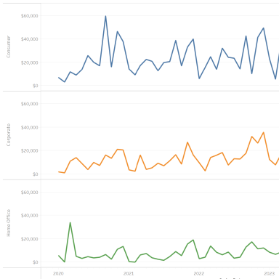

### Data Sources

|  |  |  |  |
| --- | --- | --- | --- |
| **Data Source Alias** | **Data Source Type** | **Source** | **Joins** |
| Sample - Superstore | Live | excel-direct | [Region (Orders$)] join [Region (People)] join [Order ID (Orders$)] join [Order ID (Returns)] |

### Filters

|  |  |  |  |  |  |  |
| --- | --- | --- | --- | --- | --- | --- |
| **Field Name** | **Field Selection** | **Selected Field Value(s)** | **Field Wildcard** | **Field Condition** | **Field Limit** | **Context Filter** |
| Order Date | In-Range | From 2020-01-03 to 2023-12-30 | All | None | max[#2023-12-30#], min[#2020-01-03#] | No |
| Region | Use all |  | All | None | None | No |

### Marks

|  |  |
| --- | --- |
| **Object(s) Used** | **Mark Type** |
| Segment | Color |
| Forecast Indicator | Color |

### Columns and Rows

|  |  |
| --- | --- |
| **Field Name** | **Column/Row** |
| Segment | Rows |
| Sum (Sales) | Rows |
| Month (Order Date) | Columns |

## Worksheet Name: OTE

### Worksheet was used in the following Dashboards

* Commission Model

### Data Sources

|  |  |  |  |
| --- | --- | --- | --- |
| **Data Source Alias** | **Data Source Type** | **Source** | **Joins** |
| Sales Commission | Live | textscan | None |

### Filters

|  |  |  |  |  |  |
| --- | --- | --- | --- | --- | --- |
| **Field Name** | **Field Selection** | **Field Wildcard** | **Field Condition** | **Field Limit** | **Context Filter** |
| Measure Names Sum(OTE ) | Selected from list | All | None | None | No |
| Measure Names Avg(OTE ) | Selected from list | All | None | None | No |

### Marks

|  |  |
| --- | --- |
| **Object(s) Used** | **Mark Type** |
| Measure Values | Label |

### Calculated Fields

|  |  |
| --- | --- |
| **Field Name** | **Formula** |
| Rank over 3 | ROUND(INDEX() / 3 - 0.6,0) + 1 |
| OTE (Variable) | [Base Salary] + ([Commission Rate]*[Parameters].[New Quota])/100 |

### Columns and Rows

|  |  |
| --- | --- |
| **Field Name** | **Column/Row** |
| Measure Names | Rows |

### Applied Sortings

|  |  |  |  |  |
| --- | --- | --- | --- | --- |
| **Field Name** | **Sort By** | **Sort Order** | **Aggregation Field** | **Aggregation Type** |
| Measure Names | Manual | NA | NA | NA |

## Worksheet Name: Performance

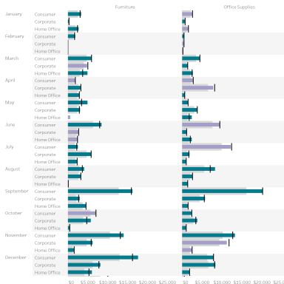

### Data Sources

|  |  |  |  |
| --- | --- | --- | --- |
| **Data Source Alias** | **Data Source Type** | **Source** | **Joins** |
| Sample - Superstore | Live | excel-direct | [Region (Orders$)] join [Region (People)] join [Order ID (Orders$)] join [Order ID (Returns)] |
| Sales Target | Live | excel-direct | None |

### Blends

|  |  |  |  |
| --- | --- | --- | --- |
| **Primary Data Source** | **Primary DS Blended Field Name** | **Secondary Data Source** | **Secondary DS Blended Field Name** |
| Sample - Superstore | Order Date (Month) | Sales Target | Order Date (Month) |
| Sample - Superstore | Category | Sales Target | Category |
| Sample - Superstore | Segment | Sales Target | Segment |
| Sample - Superstore | Order Date (Year) | Sales Target | Order Date (Year) |

### Filters

|  |  |  |  |  |  |  |
| --- | --- | --- | --- | --- | --- | --- |
| **Field Name** | **Field Selection** | **Selected Field Value(s)** | **Field Wildcard** | **Field Condition** | **Field Limit** | **Context Filter** |
| Region | Use all |  | All | None | None | No |
| Order Date | Use all |  | All | None | None | No |

### Marks

|  |  |
| --- | --- |
| **Object(s) Used** | **Mark Type** |
| Custom (Sales above Target?) | Color |
| Sum (Sales Target) | Detail |
| Custom (SUM([Sales])-SUM([Sales Target].[Sales Target])) | Detail |

### Calculated Fields

|  |  |
| --- | --- |
| **Field Name** | **Formula** |
| Sales above Target? | If Sum([Sales])>SUM([Sales Target].[Sales Target]) then "Above Target" else "Below Target" end |

### Columns and Rows

|  |  |
| --- | --- |
| **Field Name** | **Column/Row** |
| Year (Order Date) | Rows |
| Month (Order Date) | Rows |
| Segment | Rows |
| Category | Columns |
| Sum (Sales) | Columns |

## Worksheet Name: Product Detail Sheet

### Worksheet was used in the following Dashboards

* Order Details

### Data Sources

|  |  |  |  |
| --- | --- | --- | --- |
| **Data Source Alias** | **Data Source Type** | **Source** | **Joins** |
| Sample - Superstore | Live | excel-direct | [Region (Orders$)] join [Region (People)] join [Order ID (Orders$)] join [Order ID (Returns)] |

### Filters

|  |  |  |  |  |  |  |
| --- | --- | --- | --- | --- | --- | --- |
| **Field Name** | **Field Selection** | **Selected Field Value(s)** | **Field Wildcard** | **Field Condition** | **Field Limit** | **Context Filter** |
| Measure Names Sum(Sales) | Selected from list |  | All | None | None | No |
| Measure Names Sum(Quantity) | Selected from list |  | All | None | None | No |
| Measure Names Sum(Discount) | Selected from list |  | All | None | None | No |
| Measure Names Sum(Profit) | Selected from list |  | All | None | None | No |
| Measure Names (Profit Ratio) | Selected from list |  | All | None | None | No |
| Measure Names Sum(Days to Ship Scheduled) | Selected from list |  | All | None | None | No |
| Measure Names Sum(Days to Ship Actual) | Selected from list |  | All | None | None | No |
| Action (Order Profitable?,MONTH(Order Date),Segment) | Use all |  | All | None | None | No |
| Action (Postal Code,State/Province) 1 | Use all |  | All | None | None | No |
| Category | Use all |  | All | None | None | No |
| City | Excluded from list | None | All | None | None | No |
| Order Date | Manual Selection | None | All | None | None | No |
| Order Date | In-Range | From 2020-01-03 to 2023-12-30 | All | None | max[#2023-12-30#], min[#2020-01-03#] | No |
| Region | Use all |  | All | None | None | No |
| Segment | Use all |  | All | None | None | No |
| State/Province | Use all |  | All | None | None | No |

### Marks

|  |  |
| --- | --- |
| **Object(s) Used** | **Mark Type** |
| Measure Values | Label |

### Calculated Fields

|  |  |
| --- | --- |
| **Field Name** | **Formula** |
| Days to Ship Actual | DATEDIFF('day',[Order Date],[Ship Date]) |
| Days to Ship Scheduled | CASE [Ship Mode] WHEN "Same Day" THEN 0 WHEN "First Class" THEN 1 WHEN "Second Class" THEN 3 WHEN "Standard Class" THEN 6 END |
| Order Profitable? | {fixed [Order ID]:sum([Profit])}>0 // calculates the profit at the order level |
| Profit Ratio | sum([Profit])/sum([Sales]) |

### Columns and Rows

|  |  |
| --- | --- |
| **Field Name** | **Column/Row** |
| Order ID | Rows |
| Customer Name | Rows |
| Order Date | Rows |
| Ship Date | Rows |
| Ship Mode | Rows |
| Measure Names | Columns |

### Applied Sortings

|  |  |  |  |  |
| --- | --- | --- | --- | --- |
| **Field Name** | **Sort By** | **Sort Order** | **Aggregation Field** | **Aggregation Type** |
| Measure Names | Manual | NA | NA | NA |

## Worksheet Name: ProductDetails

### Worksheet was used in the following Dashboards

* Product

### Data Sources

|  |  |  |  |
| --- | --- | --- | --- |
| **Data Source Alias** | **Data Source Type** | **Source** | **Joins** |
| Sample - Superstore | Live | excel-direct | [Region (Orders$)] join [Region (People)] join [Order ID (Orders$)] join [Order ID (Returns)] |

### Filters

|  |  |  |  |  |  |  |
| --- | --- | --- | --- | --- | --- | --- |
| **Field Name** | **Field Selection** | **Selected Field Value(s)** | **Field Wildcard** | **Field Condition** | **Field Limit** | **Context Filter** |
| Action (Category,YEAR(Order Date),MONTH(Order Date)) | Use all |  | All | None | None | No |
| Action (YEAR(Order Date),MONTH(Order Date)) | Use all |  | All | None | None | No |
| Action (YEAR(Order Date),MONTH(Order Date),Product Category) | Use all |  | All | None | None | No |
| Order Date | Use all |  | All | None | None | No |
| Order Date | In-Range | From 2020-01-03 to 2023-12-30 | All | None | max[#2023-12-30#], min[#2020-01-03#] | No |
| Region | Use all |  | All | None | None | No |
| Order Date | Use all |  | All | None | None | No |

### Marks

|  |  |
| --- | --- |
| **Object(s) Used** | **Mark Type** |
| Custom (Profit Ratio) | Color |
| Product Name | Detail |
| Category | Detail |
| Sum (Profit) | Detail |

### Calculated Fields

|  |  |
| --- | --- |
| **Field Name** | **Formula** |
| Profit Ratio | sum([Profit])/sum([Sales]) |

### Columns and Rows

|  |  |
| --- | --- |
| **Field Name** | **Column/Row** |
| Category | Rows |
| Sub-Category | Rows |
| Segment | Columns |
| Sum (Sales) | Columns |

## Worksheet Name: ProductView

### Worksheet was used in the following Dashboards

* Product

### Data Sources

|  |  |  |  |
| --- | --- | --- | --- |
| **Data Source Alias** | **Data Source Type** | **Source** | **Joins** |
| Sample - Superstore | Live | excel-direct | [Region (Orders$)] join [Region (People)] join [Order ID (Orders$)] join [Order ID (Returns)] |

### Filters

|  |  |  |  |  |  |  |
| --- | --- | --- | --- | --- | --- | --- |
| **Field Name** | **Field Selection** | **Selected Field Value(s)** | **Field Wildcard** | **Field Condition** | **Field Limit** | **Context Filter** |
| Category | Use all |  | All | None | None | No |
| Region | Use all |  | All | None | None | No |
| Order Date | Use all |  | All | None | None | No |

### Actions

|  |  |  |  |  |
| --- | --- | --- | --- | --- |
| **Action Name** | **Source Sheet** | **Target Sheet** | **Run Action On** | **Target Filter** |
| Filter Product Sales 1 | ProductView | ProductView, ProductDetails | on-select | All |

### Marks

|  |  |
| --- | --- |
| **Object(s) Used** | **Mark Type** |
| Sum (Sales) | Color |
| Sum (Sales) | Label |
| Sum (Profit) | Tooltip |

### Columns and Rows

|  |  |
| --- | --- |
| **Field Name** | **Column/Row** |
| Category | Rows |
| Year (Order Date) | Rows |
| Month (Order Date) | Columns |

## Worksheet Name: QuotaAttainment

### Worksheet was used in the following Dashboards

* Commission Model

### Data Sources

|  |  |  |  |
| --- | --- | --- | --- |
| **Data Source Alias** | **Data Source Type** | **Source** | **Joins** |
| Sales Commission | Live | textscan | None |

### Marks

|  |  |
| --- | --- |
| **Object(s) Used** | **Mark Type** |
| Custom (% of quota achieved) | Label |
| Custom (Achieved Quota) | Color |
| New Quota | Detail |
| Custom (Total Compensation) | Detail |
| Maximum (OTE (Variable)) | Detail |
| Custom (Total Compensation) | Detail |

### Calculated Fields

|  |  |
| --- | --- |
| **Field Name** | **Formula** |
| Achievement (estimated) | [Sales] |
| Achieved Quota | if SUM([Achievement (estimated)]) >= [New Quota] then "100% +" elseif SUM([Achievement (estimated)]) >= 0.75 * [New Quota] then "75-100%" elseif SUM([Achievement (estimated)]) >= 0.5 * [Parameters].[New Quota] then "50-75%" else "Below 50%" end |
| Base (Variable) | [Base Salary] |
| % of quota achieved | AVG([Achievement (estimated)])/[New Quota] |
| Rank over 3 | ROUND(INDEX() / 3 - 0.6,0) + 1 |
| Sort by field | if [Sort by]="Names" then 0 elseif [Sort by]="% quota descending" then -[% of quota achieved] else [% of quota achieved] end |
| Commission (Variable) | ([Commission Rate]*[Sales])/100 |
| OTE (Variable) | [Base Salary] + ([Commission Rate]*[Parameters].[New Quota])/100 |
| Total Compensation | MIN([Base (Variable)]) + SUM([Commission (Variable)]) |

### Columns and Rows

|  |  |
| --- | --- |
| **Field Name** | **Column/Row** |
| Custom (Rank over 3) | Rows |
| Sales Person | Rows |
| Sum (Achievement (estimated)) | Columns |

### Applied Sortings

|  |  |  |  |  |
| --- | --- | --- | --- | --- |
| **Field Name** | **Sort By** | **Sort Order** | **Aggregation Field** | **Aggregation Type** |
| Sales Person | Field | Ascending | Sort by field | Custom |
| Achieved Quota | Manual | NA | NA | NA |

## Worksheet Name: Sale Map

### Worksheet was used in the following Dashboards

* Overview

### Data Sources

|  |  |  |  |
| --- | --- | --- | --- |
| **Data Source Alias** | **Data Source Type** | **Source** | **Joins** |
| Sample - Superstore | Live | excel-direct | [Region (Orders$)] join [Region (People)] join [Order ID (Orders$)] join [Order ID (Returns)] |

### Filters

|  |  |  |  |  |  |  |
| --- | --- | --- | --- | --- | --- | --- |
| **Field Name** | **Field Selection** | **Selected Field Value(s)** | **Field Wildcard** | **Field Condition** | **Field Limit** | **Context Filter** |
| Order Profitable? | Selected from list | false, true | All | None | None | No |
| Order Date | In-Range | From 2020-01-03 to 2023-12-30 | All | None | max[#2023-12-30#], min[#2020-01-03#] | No |
| Region | Use all |  | All | None | None | No |
| Profit Ratio | In-Range | From -0.22 to 0.37 | All | None | None | No |

### Actions

|  |  |  |  |  |
| --- | --- | --- | --- | --- |
| **Action Name** | **Source Sheet** | **Target Sheet** | **Run Action On** | **Target Filter** |
| State/Province Filter 1 | Sale Map | Total Sales, Sales by Segment, Sales by Product | on-select | Selected (State/Province) |
| State/Province Highlight (map) 1 | Total Sales, Sale Map | Total Sales, Sale Map | on-select | Selected (State/Province) |

### Marks

|  |  |
| --- | --- |
| **Object(s) Used** | **Mark Type** |
| Custom (Profit Ratio) | Color |
| State/Province | Detail |
| Country/Region | Detail |
| Tooltip: Profit Ratio by City | Viz in Tooltip |

### Calculated Fields

|  |  |
| --- | --- |
| **Field Name** | **Formula** |
| Order Profitable? | {fixed [Order ID]:sum([Profit])}>0 // calculates the profit at the order level |
| Profit Ratio | sum([Profit])/sum([Sales]) |

### Columns and Rows

|  |  |
| --- | --- |
| **Field Name** | **Column/Row** |
| Latitude (generated) | Rows |
| Longitude (generated) | Columns |

## Worksheet Name: Sales

### Worksheet was used in the following Dashboards

* Commission Model

### Data Sources

|  |  |  |  |
| --- | --- | --- | --- |
| **Data Source Alias** | **Data Source Type** | **Source** | **Joins** |
| Sales Commission | Live | textscan | None |

### Filters

|  |  |  |  |  |  |
| --- | --- | --- | --- | --- | --- |
| **Field Name** | **Field Selection** | **Field Wildcard** | **Field Condition** | **Field Limit** | **Context Filter** |
| Measure Names Sum(Sales) | Selected from list | All | None | None | No |
| Measure Names (% of quota achieved) | Selected from list | All | None | None | No |

### Marks

|  |  |
| --- | --- |
| **Object(s) Used** | **Mark Type** |
| Measure Values | Label |

### Calculated Fields

|  |  |
| --- | --- |
| **Field Name** | **Formula** |
| Achievement (estimated) | [Sales] |
| % of quota achieved | AVG([Achievement (estimated)])/[New Quota] |

### Columns and Rows

|  |  |
| --- | --- |
| **Field Name** | **Column/Row** |
| Measure Names | Rows |

### Applied Sortings

|  |  |  |  |  |
| --- | --- | --- | --- | --- |
| **Field Name** | **Sort By** | **Sort Order** | **Aggregation Field** | **Aggregation Type** |
| Measure Names | Manual | NA | NA | NA |

## Worksheet Name: Sales by Product

### Worksheet was used in the following Dashboards

* Overview

### Data Sources

|  |  |  |  |
| --- | --- | --- | --- |
| **Data Source Alias** | **Data Source Type** | **Source** | **Joins** |
| Sample - Superstore | Live | excel-direct | [Region (Orders$)] join [Region (People)] join [Order ID (Orders$)] join [Order ID (Returns)] |

### Filters

|  |  |  |  |  |  |  |
| --- | --- | --- | --- | --- | --- | --- |
| **Field Name** | **Field Selection** | **Selected Field Value(s)** | **Field Wildcard** | **Field Condition** | **Field Limit** | **Context Filter** |
| Action (MONTH(Order Date),Segment) | Use all |  | All | None | None | No |
| Action (Postal Code,State/Province) | Use all |  | All | None | None | No |
| Action (State/Province) | Use all |  | All | None | None | No |
| Order Profitable? | Selected from list | false, true | All | None | None | No |
| Order Date | In-Range | From 2020-01-03 to 2023-12-30 | All | None | max[#2023-12-30#], min[#2020-01-03#] | No |
| Region | Use all |  | All | None | None | No |

### Actions

|  |  |  |  |  |
| --- | --- | --- | --- | --- |
| **Action Name** | **Source Sheet** | **Target Sheet** | **Run Action On** | **Target Filter** |
| Month Highlight 1 | Total Sales, Sales by Segment, Sales by Product | Total Sales, Sales by Segment, Sales by Product | on-select | Selected (MONTH(Order Date),Order Profitable?) |

### Marks

|  |  |
| --- | --- |
| **Object(s) Used** | **Mark Type** |
| Order Profitable? | Color |
| Sum (Profit) | Tooltip |

### Calculated Fields

|  |  |
| --- | --- |
| **Field Name** | **Formula** |
| Order Profitable? | {fixed [Order ID]:sum([Profit])}>0 // calculates the profit at the order level |

### Columns and Rows

|  |  |
| --- | --- |
| **Field Name** | **Column/Row** |
| Category | Rows |
| Sum (Sales) | Rows |
| Month (Order Date) | Columns |

### Applied Sortings

|  |  |  |  |  |
| --- | --- | --- | --- | --- |
| **Field Name** | **Sort By** | **Sort Order** | **Aggregation Field** | **Aggregation Type** |
| Order Profitable? | Manual | NA | NA | NA |

## Worksheet Name: Sales by Segment

### Worksheet was used in the following Dashboards

* Overview

### Data Sources

|  |  |  |  |
| --- | --- | --- | --- |
| **Data Source Alias** | **Data Source Type** | **Source** | **Joins** |
| Sample - Superstore | Live | excel-direct | [Region (Orders$)] join [Region (People)] join [Order ID (Orders$)] join [Order ID (Returns)] |

### Filters

|  |  |  |  |  |  |  |
| --- | --- | --- | --- | --- | --- | --- |
| **Field Name** | **Field Selection** | **Selected Field Value(s)** | **Field Wildcard** | **Field Condition** | **Field Limit** | **Context Filter** |
| Action (MONTH(Order Date),Product Category) | Use all |  | All | None | None | No |
| Action (Postal Code,State/Province) | Use all |  | All | None | None | No |
| Action (State/Province) | Use all |  | All | None | None | No |
| Order Profitable? | Selected from list | false, true | All | None | None | No |
| Order Date | In-Range | From 2020-01-03 to 2023-12-30 | All | None | max[#2023-12-30#], min[#2020-01-03#] | No |
| Region | Use all |  | All | None | None | No |

### Actions

|  |  |  |  |  |
| --- | --- | --- | --- | --- |
| **Action Name** | **Source Sheet** | **Target Sheet** | **Run Action On** | **Target Filter** |
| Month Highlight 1 | Total Sales, Sales by Segment, Sales by Product | Total Sales, Sales by Segment, Sales by Product | on-select | Selected (MONTH(Order Date),Order Profitable?) |

### Marks

|  |  |
| --- | --- |
| **Object(s) Used** | **Mark Type** |
| Order Profitable? | Color |
| Sum (Profit) | Tooltip |

### Calculated Fields

|  |  |
| --- | --- |
| **Field Name** | **Formula** |
| Order Profitable? | {fixed [Order ID]:sum([Profit])}>0 // calculates the profit at the order level |

### Columns and Rows

|  |  |
| --- | --- |
| **Field Name** | **Column/Row** |
| Segment | Rows |
| Sum (Sales) | Rows |
| Month (Order Date) | Columns |

### Applied Sortings

|  |  |  |  |  |
| --- | --- | --- | --- | --- |
| **Field Name** | **Sort By** | **Sort Order** | **Aggregation Field** | **Aggregation Type** |
| Order Profitable? | Manual | NA | NA | NA |

## Worksheet Name: ShipSummary

### Worksheet was used in the following Dashboards

* Shipping

### Data Sources

|  |  |  |  |
| --- | --- | --- | --- |
| **Data Source Alias** | **Data Source Type** | **Source** | **Joins** |
| Sample - Superstore | Live | excel-direct | [Region (Orders$)] join [Region (People)] join [Order ID (Orders$)] join [Order ID (Returns)] |

### Filters

|  |  |  |  |  |  |  |
| --- | --- | --- | --- | --- | --- | --- |
| **Field Name** | **Field Selection** | **Selected Field Value(s)** | **Field Wildcard** | **Field Condition** | **Field Limit** | **Context Filter** |
| Ship Status | Use all |  | All | None | None | No |
| Region | Use all |  | All | None | None | No |
| Ship Mode | Use all |  | All | None | None | No |
| Order Date | Selected from list | Q4 | All | None | None | No |
| Order Date | Selected from list | 2023 | All | None | None | No |

### Actions

|  |  |  |  |  |
| --- | --- | --- | --- | --- |
| **Action Name** | **Source Sheet** | **Target Sheet** | **Run Action On** | **Target Filter** |
| Filter 1 (generated) 1 | ShipSummary | ShipSummary, ShippingTrend, DaystoShip | on-select | All |

### Marks

|  |  |
| --- | --- |
| **Object(s) Used** | **Mark Type** |
| Ship Status | Color |
| Count (Orders) | Label |
| Ship Status | Label |

### Calculated Fields

|  |  |
| --- | --- |
| **Field Name** | **Formula** |
| Days to Ship Actual | DATEDIFF('day',[Order Date],[Ship Date]) |
| Ship Status | if [Days to Ship Actual]> [Days to Ship Scheduled] then "Shipped Late" elseIF [Days to Ship Actual]= [Days to Ship Scheduled] then "Shipped On Time" Else "Shipped Early" end |
| Days to Ship Scheduled | CASE [Ship Mode] WHEN "Same Day" THEN 0 WHEN "First Class" THEN 1 WHEN "Second Class" THEN 3 WHEN "Standard Class" THEN 6 END |

### Columns and Rows

|  |  |
| --- | --- |
| **Field Name** | **Column/Row** |
| Count (Orders) | Columns |

### Applied Sortings

|  |  |  |  |  |
| --- | --- | --- | --- | --- |
| **Field Name** | **Sort By** | **Sort Order** | **Aggregation Field** | **Aggregation Type** |
| Ship Status | Manual | NA | NA | NA |

## Worksheet Name: ShippingTrend

### Worksheet was used in the following Dashboards

* Shipping

### Data Sources

|  |  |  |  |
| --- | --- | --- | --- |
| **Data Source Alias** | **Data Source Type** | **Source** | **Joins** |
| Sample - Superstore | Live | excel-direct | [Region (Orders$)] join [Region (People)] join [Order ID (Orders$)] join [Order ID (Returns)] |

### Filters

|  |  |  |  |  |  |  |
| --- | --- | --- | --- | --- | --- | --- |
| **Field Name** | **Field Selection** | **Selected Field Value(s)** | **Field Wildcard** | **Field Condition** | **Field Limit** | **Context Filter** |
| Action (Delayed?) | Use all |  | All | None | None | No |
| Action (Ship Status) | Use all |  | All | None | None | No |
| Region | Use all |  | All | None | None | No |
| Ship Mode | Use all |  | All | None | None | No |
| Order Date | Selected from list | Q4 | All | None | None | No |
| Order Date | Selected from list | 2023 | All | None | None | No |

### Actions

|  |  |  |  |  |
| --- | --- | --- | --- | --- |
| **Action Name** | **Source Sheet** | **Target Sheet** | **Run Action On** | **Target Filter** |
| Filter Details 1 | ShippingTrend | ShippingTrend, DaystoShip | on-select | All |

### Marks

|  |  |
| --- | --- |
| **Object(s) Used** | **Mark Type** |
| Ship Status | Color |

### Calculated Fields

|  |  |
| --- | --- |
| **Field Name** | **Formula** |
| Days to Ship Actual | DATEDIFF('day',[Order Date],[Ship Date]) |
| Ship Status | if [Days to Ship Actual]> [Days to Ship Scheduled] then "Shipped Late" elseIF [Days to Ship Actual]= [Days to Ship Scheduled] then "Shipped On Time" Else "Shipped Early" end |
| Days to Ship Scheduled | CASE [Ship Mode] WHEN "Same Day" THEN 0 WHEN "First Class" THEN 1 WHEN "Second Class" THEN 3 WHEN "Standard Class" THEN 6 END |

### Columns and Rows

|  |  |
| --- | --- |
| **Field Name** | **Column/Row** |
| Count (Orders) | Rows |
| Year (Order Date) | Columns |
| Week (Order Date) | Columns |

### Applied Sortings

|  |  |  |  |  |
| --- | --- | --- | --- | --- |
| **Field Name** | **Sort By** | **Sort Order** | **Aggregation Field** | **Aggregation Type** |
| Ship Status | Manual | NA | NA | NA |

## Worksheet Name: Tooltip: Profit Ratio by City

### Data Sources

|  |  |  |  |
| --- | --- | --- | --- |
| **Data Source Alias** | **Data Source Type** | **Source** | **Joins** |
| Sample - Superstore | Live | excel-direct | [Region (Orders$)] join [Region (People)] join [Order ID (Orders$)] join [Order ID (Returns)] |

### Filters

|  |  |  |  |  |  |  |
| --- | --- | --- | --- | --- | --- | --- |
| **Field Name** | **Field Selection** | **Selected Field Value(s)** | **Field Wildcard** | **Field Condition** | **Field Limit** | **Context Filter** |
| Tooltip (Country/Region,State/Province) | Use all |  | All | None | None | No |
| Tooltip (State/Province) | Use all |  | All | None | None | No |
| Order Date | In-Range | From 2020-01-03 to 2023-12-30 | All | None | max[#2023-12-30#], min[#2020-01-03#] | No |

### Marks

|  |  |
| --- | --- |
| **Object(s) Used** | **Mark Type** |
| Custom (Profit Ratio) | Color |

### Calculated Fields

|  |  |
| --- | --- |
| **Field Name** | **Formula** |
| Profit Ratio | sum([Profit])/sum([Sales]) |

### Applied Sortings

|  |  |  |  |  |
| --- | --- | --- | --- | --- |
| **Field Name** | **Sort By** | **Sort Order** | **Aggregation Field** | **Aggregation Type** |
| City | Field | Ascending | Profit Ratio | Custom |

## Worksheet Name: Total Sales

### Worksheet was used in the following Dashboards

* Overview

### Data Sources

|  |  |  |  |
| --- | --- | --- | --- |
| **Data Source Alias** | **Data Source Type** | **Source** | **Joins** |
| Sample - Superstore | Live | excel-direct | [Region (Orders$)] join [Region (People)] join [Order ID (Orders$)] join [Order ID (Returns)] |

### Filters

|  |  |  |  |  |  |  |
| --- | --- | --- | --- | --- | --- | --- |
| **Field Name** | **Field Selection** | **Selected Field Value(s)** | **Field Wildcard** | **Field Condition** | **Field Limit** | **Context Filter** |
| Measure Names Sum(Sales) | Selected from list |  | All | None | None | No |
| Measure Names Sum(Profit) | Selected from list |  | All | None | None | No |
| Measure Names (Profit Ratio) | Selected from list |  | All | None | None | No |
| Measure Names (Sales per Customer ) | Selected from list |  | All | None | None | No |
| Measure Names (Sales per Customer) | Selected from list |  | All | None | None | No |
| Measure Names Avg(Discount) | Selected from list |  | All | None | None | No |
| Measure Names Sum(Quantity) | Selected from list |  | All | None | None | No |
| Action (Order Profitable?,Category,MONTH(Order Date)) | Use all |  | All | None | None | No |
| Action (Order Profitable?,MONTH(Order Date),Segment) | Use all |  | All | None | None | No |
| Action (State/Province) | Use all |  | All | None | None | No |
| Order Date | In-Range | From 2020-01-03 to 2023-12-30 | All | None | max[#2023-12-30#], min[#2020-01-03#] | No |
| Region | Use all |  | All | None | None | No |

### Actions

|  |  |  |  |  |
| --- | --- | --- | --- | --- |
| **Action Name** | **Source Sheet** | **Target Sheet** | **Run Action On** | **Target Filter** |
| State/Province Highlight (map) 1 | Total Sales, Sale Map | Total Sales, Sale Map | on-select | Selected (State/Province) |
| Month Highlight 1 | Total Sales, Sales by Segment, Sales by Product | Total Sales, Sales by Segment, Sales by Product | on-select | Selected (MONTH(Order Date),Order Profitable?) |

### Marks

|  |  |
| --- | --- |
| **Object(s) Used** | **Mark Type** |
| Measure Values | Label |

### Calculated Fields

|  |  |
| --- | --- |
| **Field Name** | **Formula** |
| Sales Forecast | [Sales]*(1-[Churn Rate])*(1+[New Business Growth]) |
| Order Profitable? | {fixed [Order ID]:sum([Profit])}>0 // calculates the profit at the order level |
| Sales per Customer | Sum([Sales])/countD([Customer Name]) |
| Profit Ratio | sum([Profit])/sum([Sales]) |
| Units estimate | ROUND([Quantity]*(1-[Churn Rate])*(1+[New Business Growth]),0) |
| Profit per Order | Sum([Profit])/countD([Order ID]) |

### Columns and Rows

|  |  |
| --- | --- |
| **Field Name** | **Column/Row** |
| Measure Names | Columns |

### Applied Sortings

|  |  |  |  |  |
| --- | --- | --- | --- | --- |
| **Field Name** | **Sort By** | **Sort Order** | **Aggregation Field** | **Aggregation Type** |
| Measure Names | Manual | NA | NA | NA |

## Worksheet Name: What If Forecast

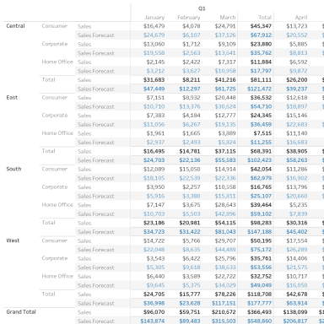

### Data Sources

|  |  |  |  |
| --- | --- | --- | --- |
| **Data Source Alias** | **Data Source Type** | **Source** | **Joins** |
| Sample - Superstore | Live | excel-direct | [Region (Orders$)] join [Region (People)] join [Order ID (Orders$)] join [Order ID (Returns)] |

### Filters

|  |  |  |  |  |  |  |
| --- | --- | --- | --- | --- | --- | --- |
| **Field Name** | **Field Selection** | **Selected Field Value(s)** | **Field Wildcard** | **Field Condition** | **Field Limit** | **Context Filter** |
| Measure Names Sum(Sales) | Selected from list |  | All | None | None | No |
| Measure Names Sum(Sales Forecast) | Selected from list |  | All | None | None | No |
| Order Date | In-Range | From 2020-01-03 to 2023-12-30 | All | None | max[#2023-12-30#], min[#2020-01-03#] | No |
| Region | Use all |  | All | None | None | No |
| Order Date | Use all |  | All | None | None | No |

### Marks

|  |  |
| --- | --- |
| **Object(s) Used** | **Mark Type** |
| Measure Names | Color |
| Measure Values | Label |
| Custom (SUM([Sales])-SUM([Sales Forecast])) | Detail |
| Sum (Sales) | Detail |
| Sum (Sales Forecast) | Detail |

### Calculated Fields

|  |  |
| --- | --- |
| **Field Name** | **Formula** |
| Sales Forecast | [Sales]*(1-[Churn Rate])*(1+[New Business Growth]) |

### Columns and Rows

|  |  |
| --- | --- |
| **Field Name** | **Column/Row** |
| Region | Rows |
| Segment | Rows |
| Measure Names | Rows |
| Quarter (Order Date) | Columns |
| Month (Order Date) | Columns |

### Applied Sortings

|  |  |  |  |  |
| --- | --- | --- | --- | --- |
| **Field Name** | **Sort By** | **Sort Order** | **Aggregation Field** | **Aggregation Type** |
| Measure Names | Manual | NA | NA | NA |